**ValueTag:**

Based on my Observations, I am coming up with certain features that we might include in the Index page.

1. When the URL is entered and Website is about to open, in this mean time, we can use a design given in Index.html

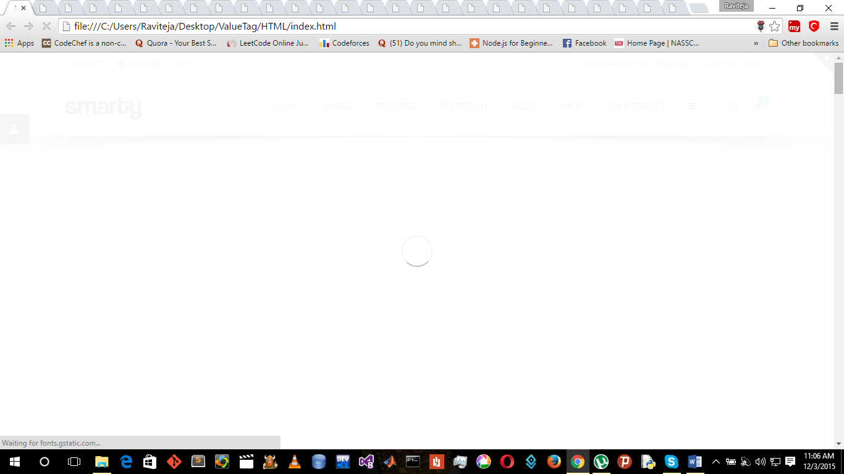

This is just to say we are browsing and about to open the page.

1. Coming to the Index page after loading. Major part to consider is **Header** of the page.

From my observation, I found out we have several headers, in various pages, few of which are of white background and the other are of transparent background.

For Index page or Landing Page of the website, a transparent big header will be more appealing.

Have a look at this. We can use any of this. Depending on the fields we are going to add to the Header. And our header shrinks when the user scrolls down and it becomes a white backgrounded header.

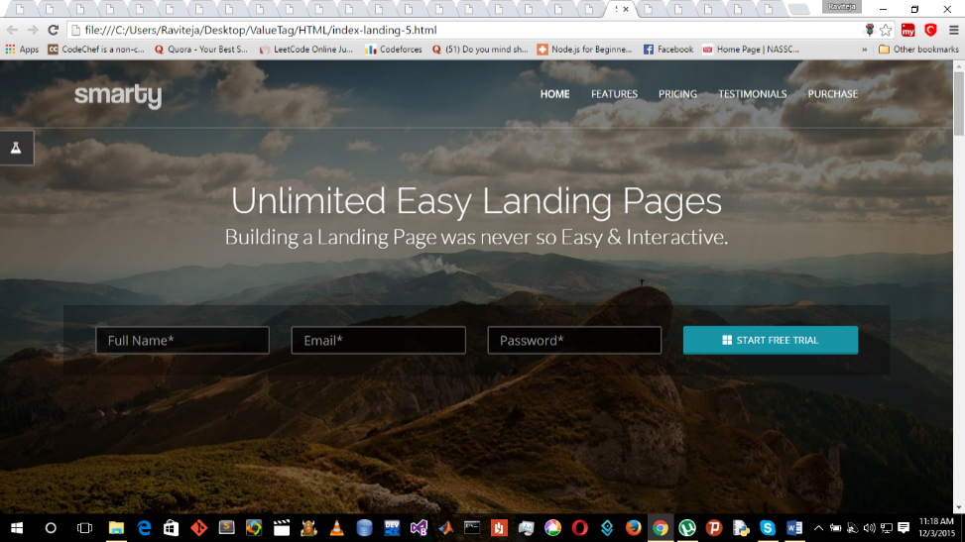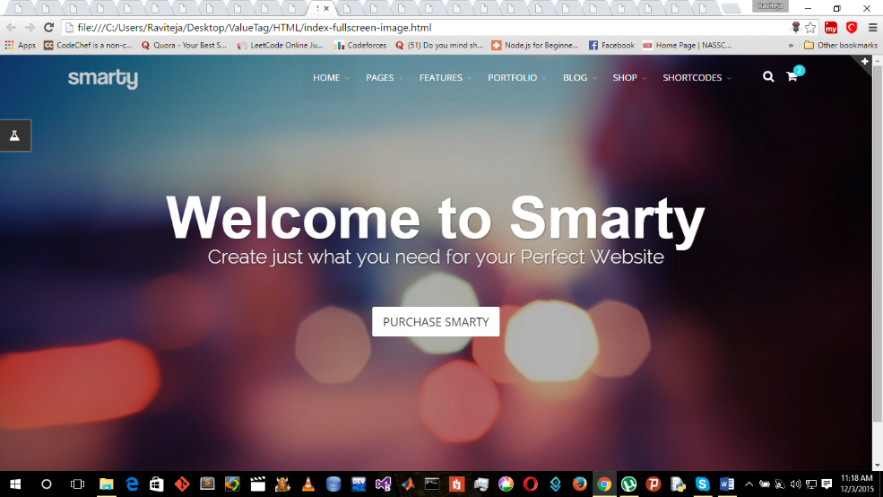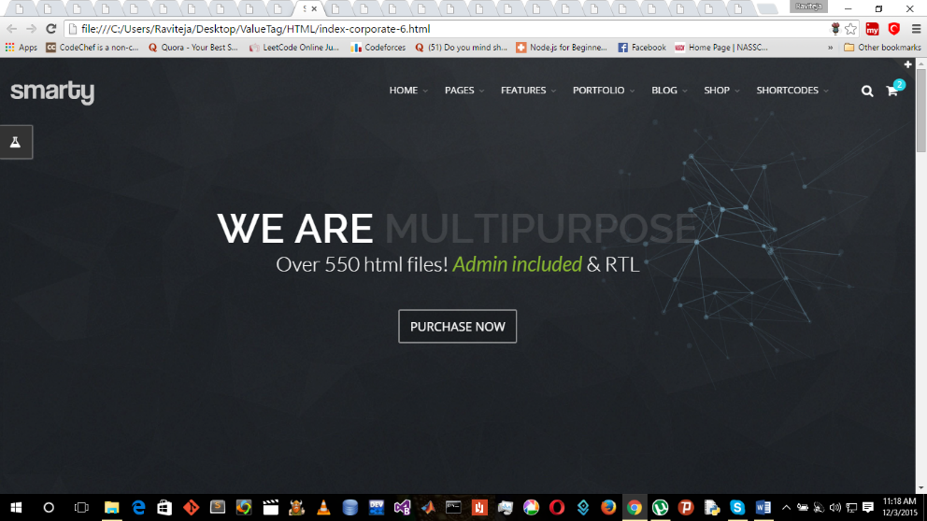

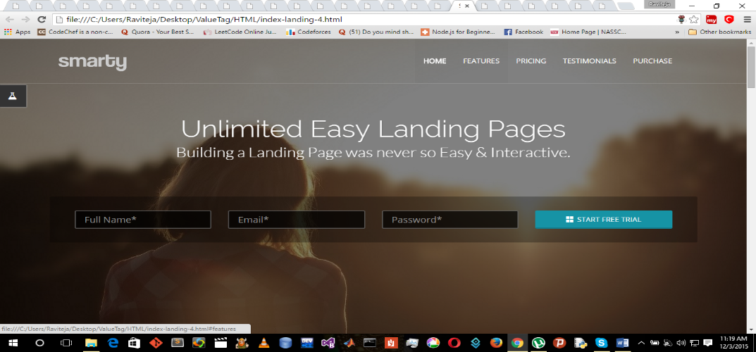

Here in the header, we can have a logo, in the left side and all the other dropdowns can be arranged in the header .In Landing Page, we don’t have a notification option. We will have an option for sign in or Log in.

1. After Header one more important part is Top View of Landing page.

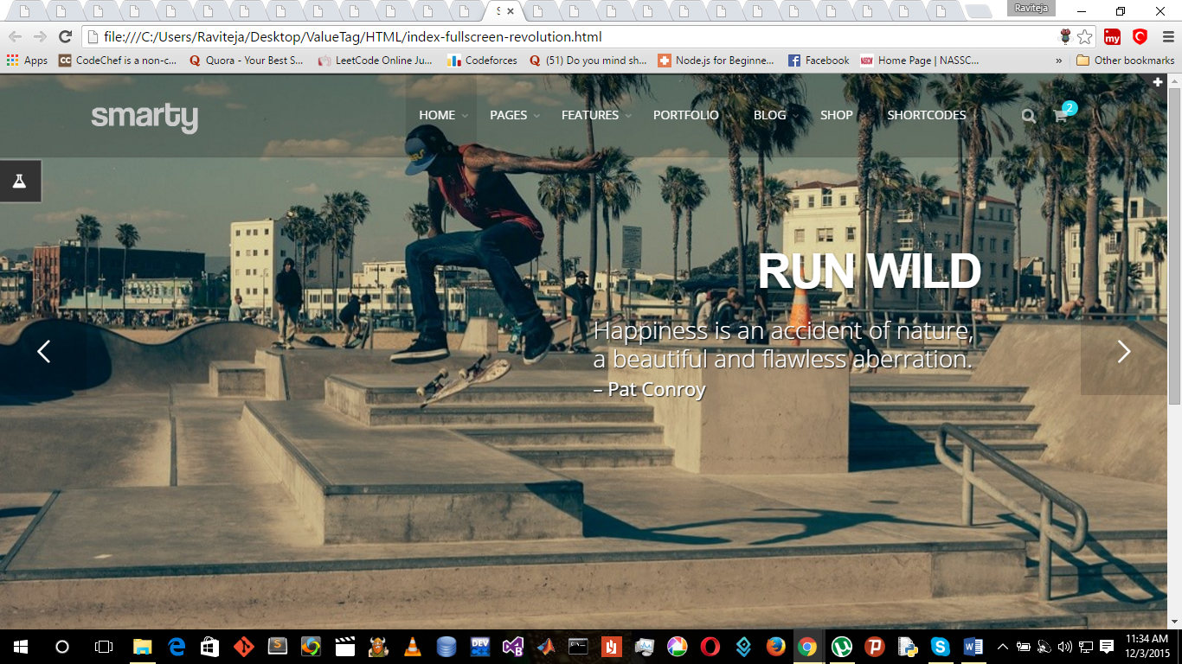Index-fullscreen-revolution.html is good and we can use this for the Top view of the Landing Page.

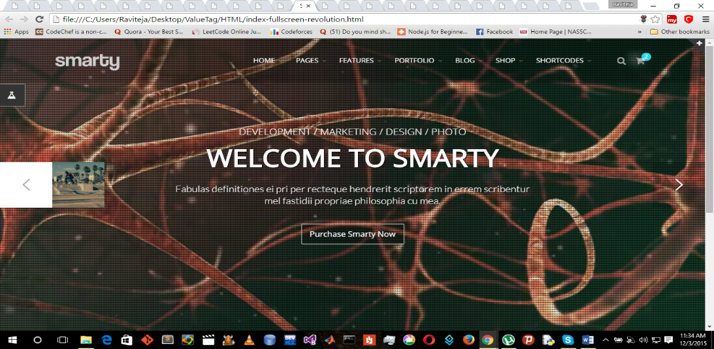

Design remain this way, Contents can be populated based on the information given.

1. Footer in index-shop-5.html looks promising.

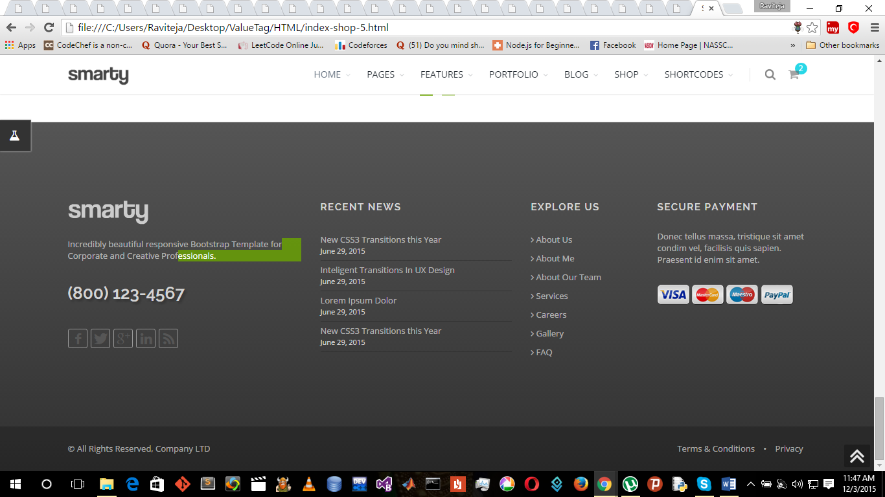

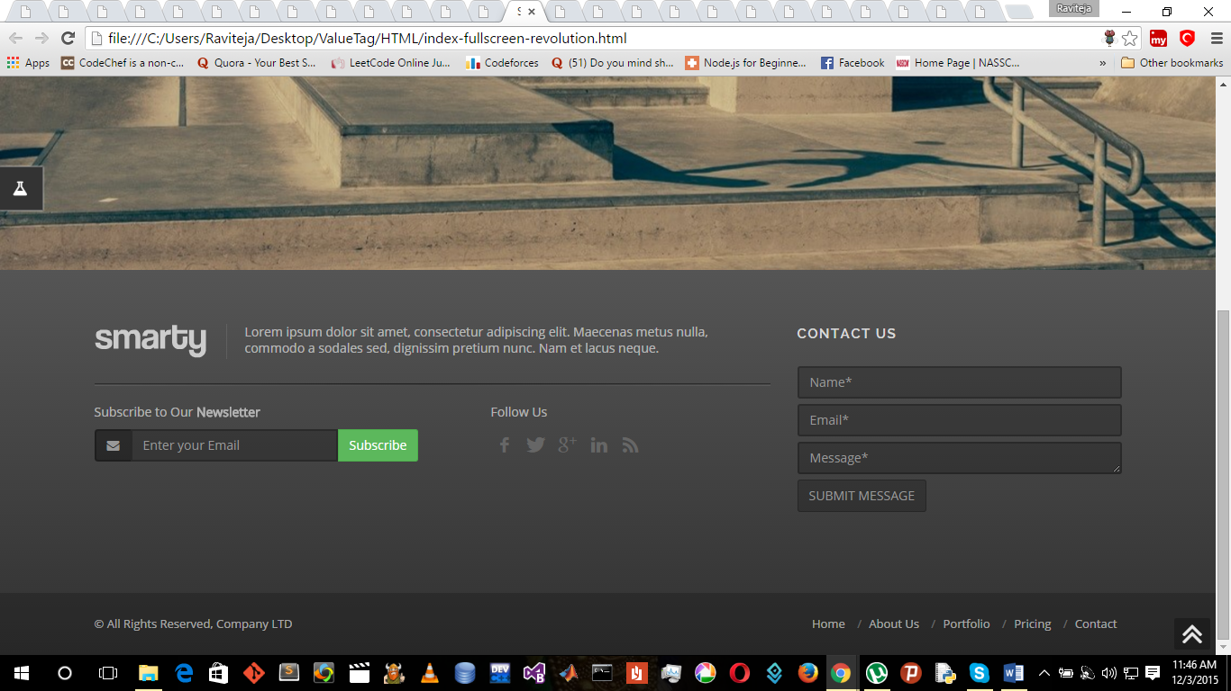Or else we can go for this footer as well.

1. Remaining, we can develop our own cards and layouts for displaying the different coupons and Vendors.

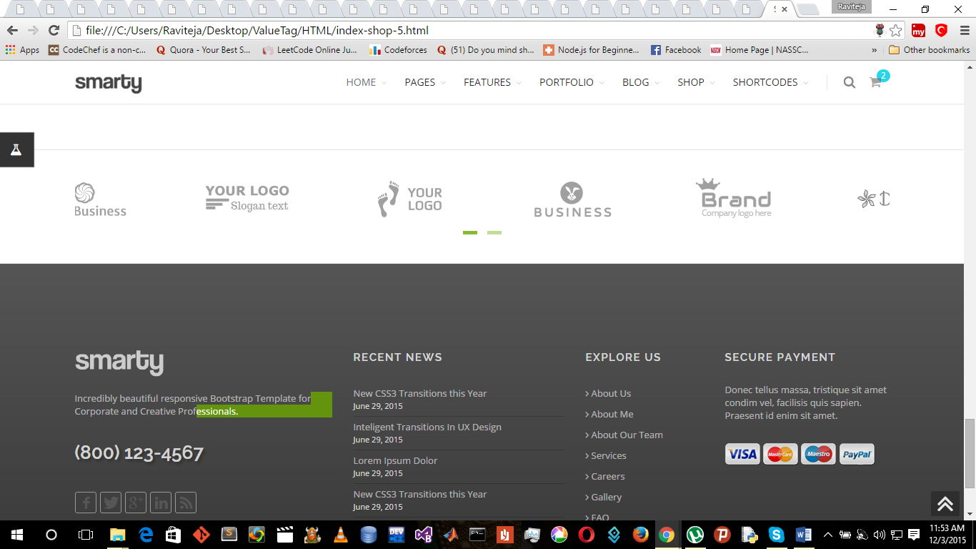For vendors this may do, but we can have a better one.

1. 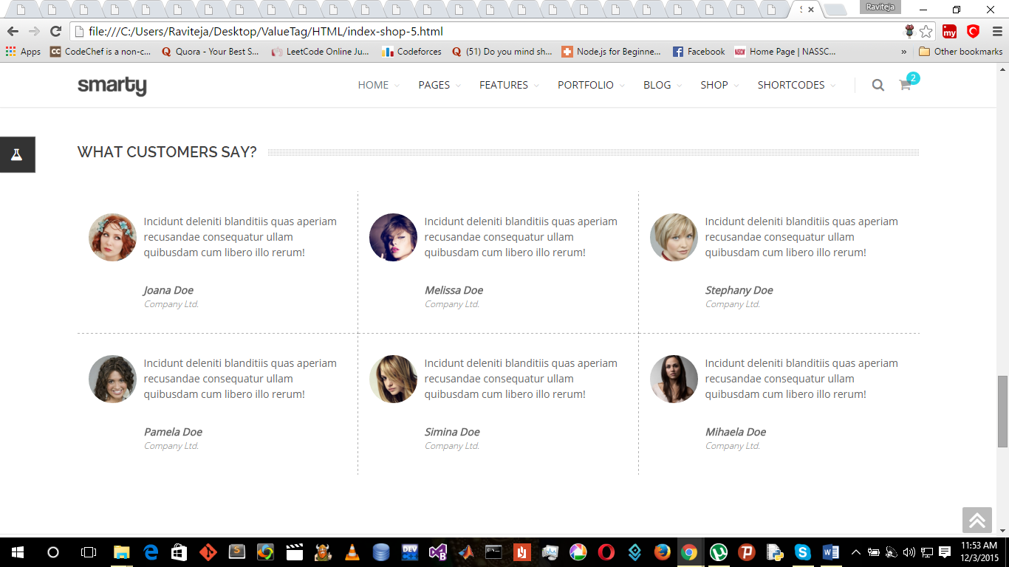For Customers feedback, we can use this. We can populate accordingly.
2. For coupons, we can use this but what I feel is we will design our own Cards, layouts for coupons. Because we may require something else than what is given here.

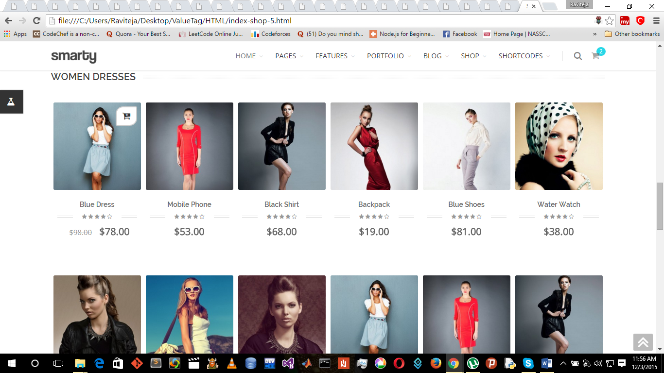

1. 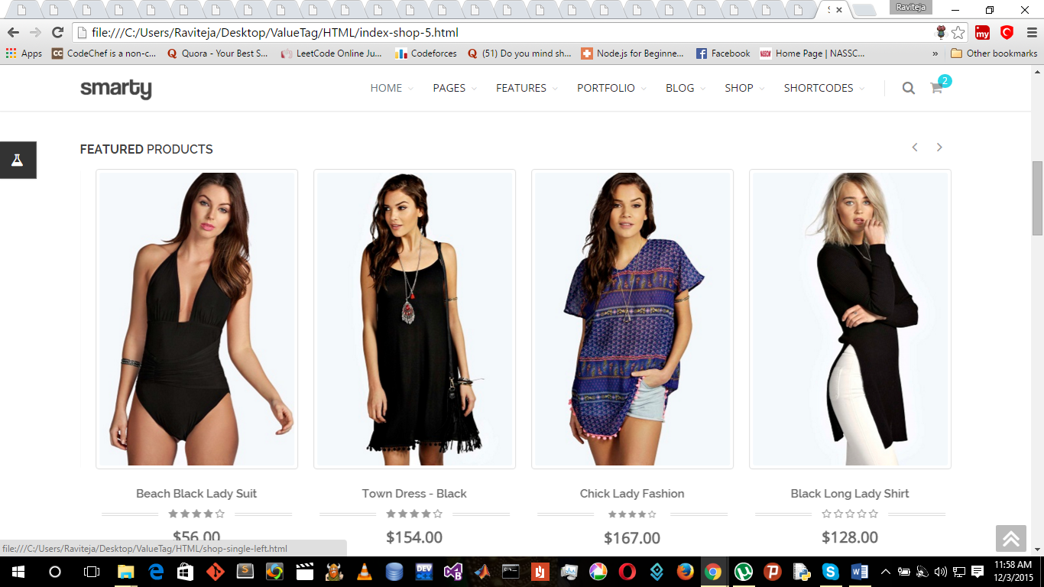We will have a featured column which shows the important coupons available that particular day. For this the cards will be of bigger size but we will have our own design.

Madam, So these are the observations I made. Give your opinion, then we can proceed further.